# VISVESVARAYA TECHNOLOGICAL UNIVERSITY

**“JnanaSangama”, Belgaum -590014, Karnataka.**



### LAB REPORT on

Artificial Intelligence LAB

***Submitted by***

### Rahul Raj (1BM21CS158)

***in partial fulfillment for the award of the degree of***

**BACHELOR OF ENGINEERING**

***in***

### COMPUTER SCIENCE AND ENGINEERING



**B.M.S. COLLEGE OF ENGINEERING BENGALURU-560019 Oct-2023 to Feb-2024**

**(Autonomous Institution under VTU)**

**B. M. S. College of Engineering,**

**Bull Temple Road, Bangalore 560019**

(Affiliated To Visvesvaraya Technological University, Belgaum)

#### Department of Computer Science and Engineering



**CERTIFICATE**

This is to certify that the Lab work entitled “Artificial Intelligence lab” carried out by **Rahul Raj (1BM21CS158),** who is a bonafide student of **B. M. S. College of Engineering.** It is in partial fulfillment for the award of **Bachelor of Engineering in Computer Science and Engineering** of the Visvesvaraya Technological University, Belgaum during the year 2023. The Lab report has been approved as it satisfies the academic requirements in respect of an **Artificial Intelligence lab (22CS5PCAIN)** work prescribed for the said degree.

**Dr. Pallavi GB Dr.Jyothi S Nayak**

Assistant Professor Professor and Head

Department of CSE Department of CSE

BMSCE, Bengaluru BMSCE, Bengaluru

`

**Program 1:**

**Implement the vacuum cleaner program(20/11/23)**

def vacuum_world():

# initializing goal_state

# 0 indicates Clean and 1 indicates Dirty goal_state = {'A': '0', 'B': '0'} cost = 0

location_input = input("Enter Location of Vacuum") #user_input of location vacuum is placed status_input = input("Enter status of " + location_input) #user_input if location is dirty or clean status_input_complement = input("Enter status of other room")

print("Initial Location Condition" + str(goal_state)) if location_input == 'A':

# Location A is Dirty.

print("Vacuum is placed in Location A") if status_input == '1': print("Location A is Dirty.") # suck the dirt and mark it as clean

goal_state['A'] = '0' cost += 1 #cost for suck print("Cost for CLEANING A " + str(cost)) print("Location A has been Cleaned.") if status_input_complement == '1':

# if B is Dirty

print("Location B is Dirty.") print("Moving right to the Location B. ")

cost += 1 #cost for moving right

print("COST for moving RIGHT" + str(cost)) # suck the dirt and mark it as clean

goal_state['B'] = '0' cost += 1 #cost for suck print("COST for SUCK " + str(cost)) print("Location B

has been Cleaned. ") else: print("No action" + str(cost))

# suck and mark clean

print("Location B is already clean.")

if status_input == '0':

print("Location A is already clean ") if status_input_complement == '1':# if B is Dirty print("Location B is Dirty.")

print("Moving RIGHT to the Location B. ") cost += 1 #cost for moving right print("COST for moving RIGHT " + str(cost)) # suck the dirt and mark it as clean goal_state['B'] = '0'

cost += 1 #cost for suck print("Cost for

SUCK" + str(cost)) print("Location B has been Cleaned. ") else:

print("No action " + str(cost)) print(cost)

# suck and mark clean print("Location B is already clean.") else:

print("Vacuum is placed in location B") # Location B is Dirty. if status_input

== '1':

print("Location B is Dirty.") # suck the dirt and mark it as clean

goal_state['B'] = '0' cost += 1 # cost for suck print("COST for CLEANING " + str(cost)) print("Location B has been Cleaned.") if status_input_complement == '1':

# if A is Dirty

print("Location A is Dirty.") print("Moving LEFT to the Location A. ") cost += 1 # cost for moving right print("COST for moving LEFT" + str(cost)) # suck the dirt and mark it as clean

goal_state['A'] = '0' cost += 1 # cost for suck print("COST for SUCK " + str(cost)) print("Location A

has been Cleaned.") else: print(cost)

# suck and mark clean print("Location B is already clean.") if status_input_complement == '1': # if A is Dirty print("Location A is Dirty.") print("Moving

LEFT to the Location A. ") cost += 1 # cost for moving right print("COST for moving LEFT " + str(cost)) # suck the dirt and mark it as clean

goal_state['A'] = '0' cost

+= 1 # cost for suck print("Cost for SUCK " + str(cost))

print("Location A has been Cleaned. ") else:

print("No action " + str(cost)) # suck and mark clean print("Location A is already clean.")

# done cleaning print("GOAL STATE: ")

print(goal_state)

print("Performance Measurement: " + str(cost)) vacuum_world()

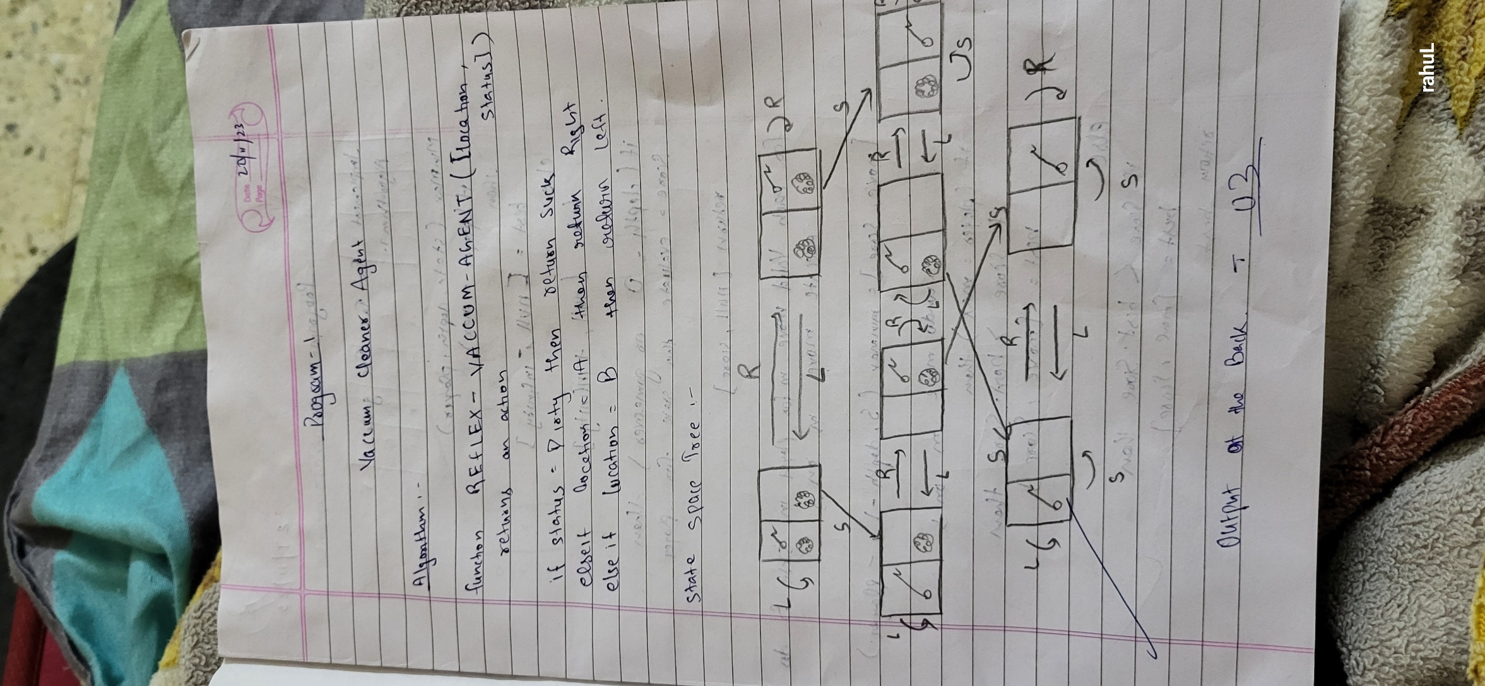

**output**

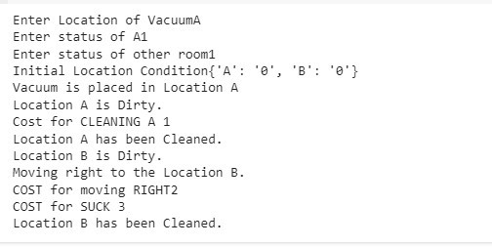

**Program 2:**

### Implement the 8 Puzzle Bíeadth Ïiíst Seaích Algoíithm.(11/12/23)

import numpy as np import pandas as pd

import os

def gen(state, m, b):

temp = state.copy()

if m == 'd': temp[b + 3], temp[b] = temp[b], temp[b + 3] elif m == 'u':

temp[b - 3], temp[b] = temp[b], temp[b - 3]

elif m == 'l': temp[b - 1], temp[b] =

temp[b], temp[b - 1] elif m == 'r':

temp[b + 1], temp[b] = temp[b], temp[b + 1] return temp # Return the modified state

def possible_moves(state, visited_states): b = state.index(0)

d = []

if b not in [0, 1,

2]:

d.append('u') if b

not in [6, 7, 8]:

d.append('d') if b

not in [0, 3, 6]:

d.append('l') if b

not in [2, 5, 8]:

d.append('r')

pos_moves_it_can = [] for i in

d:

pos_moves_it_can.append(gen(state, i, b))

return [move_it_can for move_it_can in pos_moves_it_can if move_it_can not in visited_states]

def bfs(src, target): queue = []

queue.append(src) cost=0 exp = []

while len(queue) > 0: source = queue.pop(0) exp.append(source) print("queue") for q in queue:

print(q)

print(" *** ")

print(source[0],'|',source[1],'|',source[2]) print(source[3],'|',source[4],'|', source[5]) print(source[6],'|', source[7],'|',source[8])

print() cost=cost+1

if source == target: print("success") print("path cost",cost)

return

poss_moves_to_do = possible_moves(source, exp) for move in poss_moves_to_do: if

move not in exp and move not in queue:

queue.append(move)

src = [1, 2, 3, 4, 5, 6, 0, 7, 8] target

= [1, 2, 3, 4, 5, 6, 7, 8, 0] bfs(src,

target)

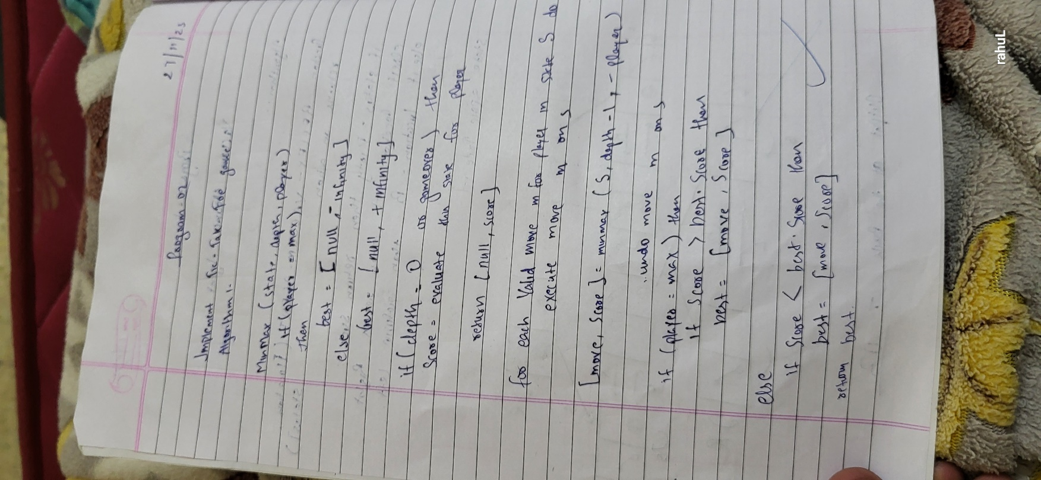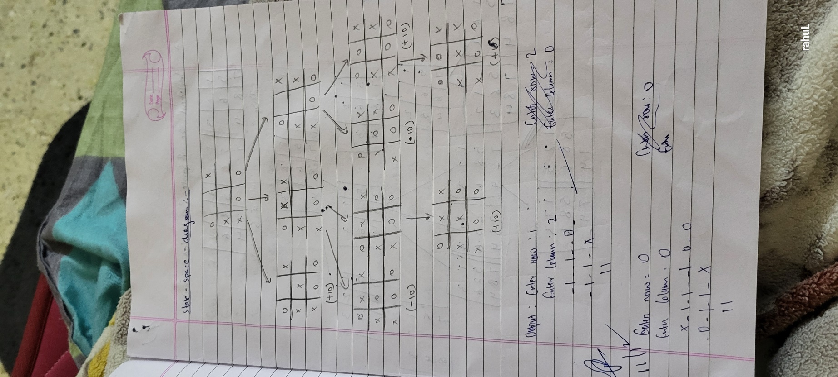

## Output

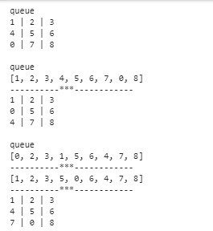

**Program 3:**

## Exploíe the woíking of ľic ľac ľoe using Min max stíategy. (11/12/23)

board = [[" ", " ", " "], [" ", " ", " "], [" ", " ", " "]]

print("0,0|0,1|0,2")

print("1,0|1,1|1,2")

print("2,0|,2,1|2,2 \n\n") def print_board(): for row in board:

print("|".join(row))

print("-" * 5)

def check_winner(player): for i in range(3): if all([board[i][j] == player for j in range(3)]) or all([board[j][i] == player for j in range(3)]): return True

if all([board[i][i] == player for i in range(3)]) or all([board[i][2 - i] == player for i in range(3)]): return True

return False

def is_full(): return all([cell != " " for row in board for cell in row])

def minimax(depth, is_maximizing): if check_winner("X"):

return -1 if check_winner("O"):

return 1 if is_full(): return

0 if is_maximizing:

max_eval = float("-inf") for i in range(3): for j in range(3): if board[i][j] == " ":

board[i][j] = "O"

eval = minimax(depth + 1, False) board[i][j] = " "

max_eval = max(max_eval, eval) return max_eval else:

min_eval = float("inf") for i in range(3):

for j in range(3): if

board[i][j] == " ":

board[i][j] = "X"

eval = minimax(depth + 1, True) board[i][j] = " "

min_eval = min(min_eval, eval) return min_eval

def ai_move(): best_move = None

best_eval = float("-inf") for i in range(3): for j in range(3): if board[i][j] == "

": board[i][j] = "O" eval = minimax(0, False)

board[i][j] = " " if eval > best_eval: best_eval = eval

best_move = (i, j) return best_move

while not is_full() and not check_winner("X") and not check_winner("O"): print_board() row = int(input("Enter row (0, 1, or 2): ")) col = int(input("Enter column (0, 1, or 2): ")) if board[row][col] == " ": board[row][col] = "X" if check_winner("X"): print_board() print("You win!") break if is_full(): print_board() print("It's a draw!") break

ai_row, ai_col = ai_move() board[ai_row][ai_col] = "O"

if check_winner("O"): print_board() print("AI wins!")

break

else:

print("Cell is already occupied. Try again.")

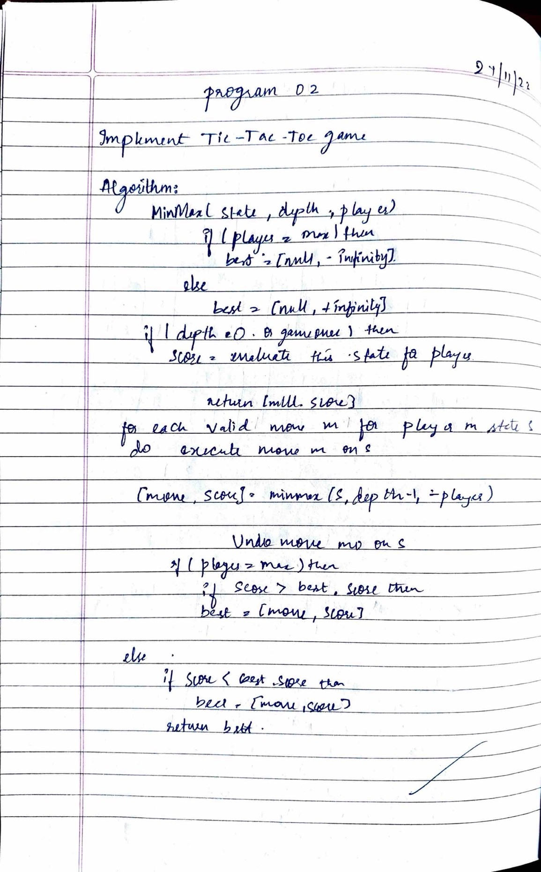

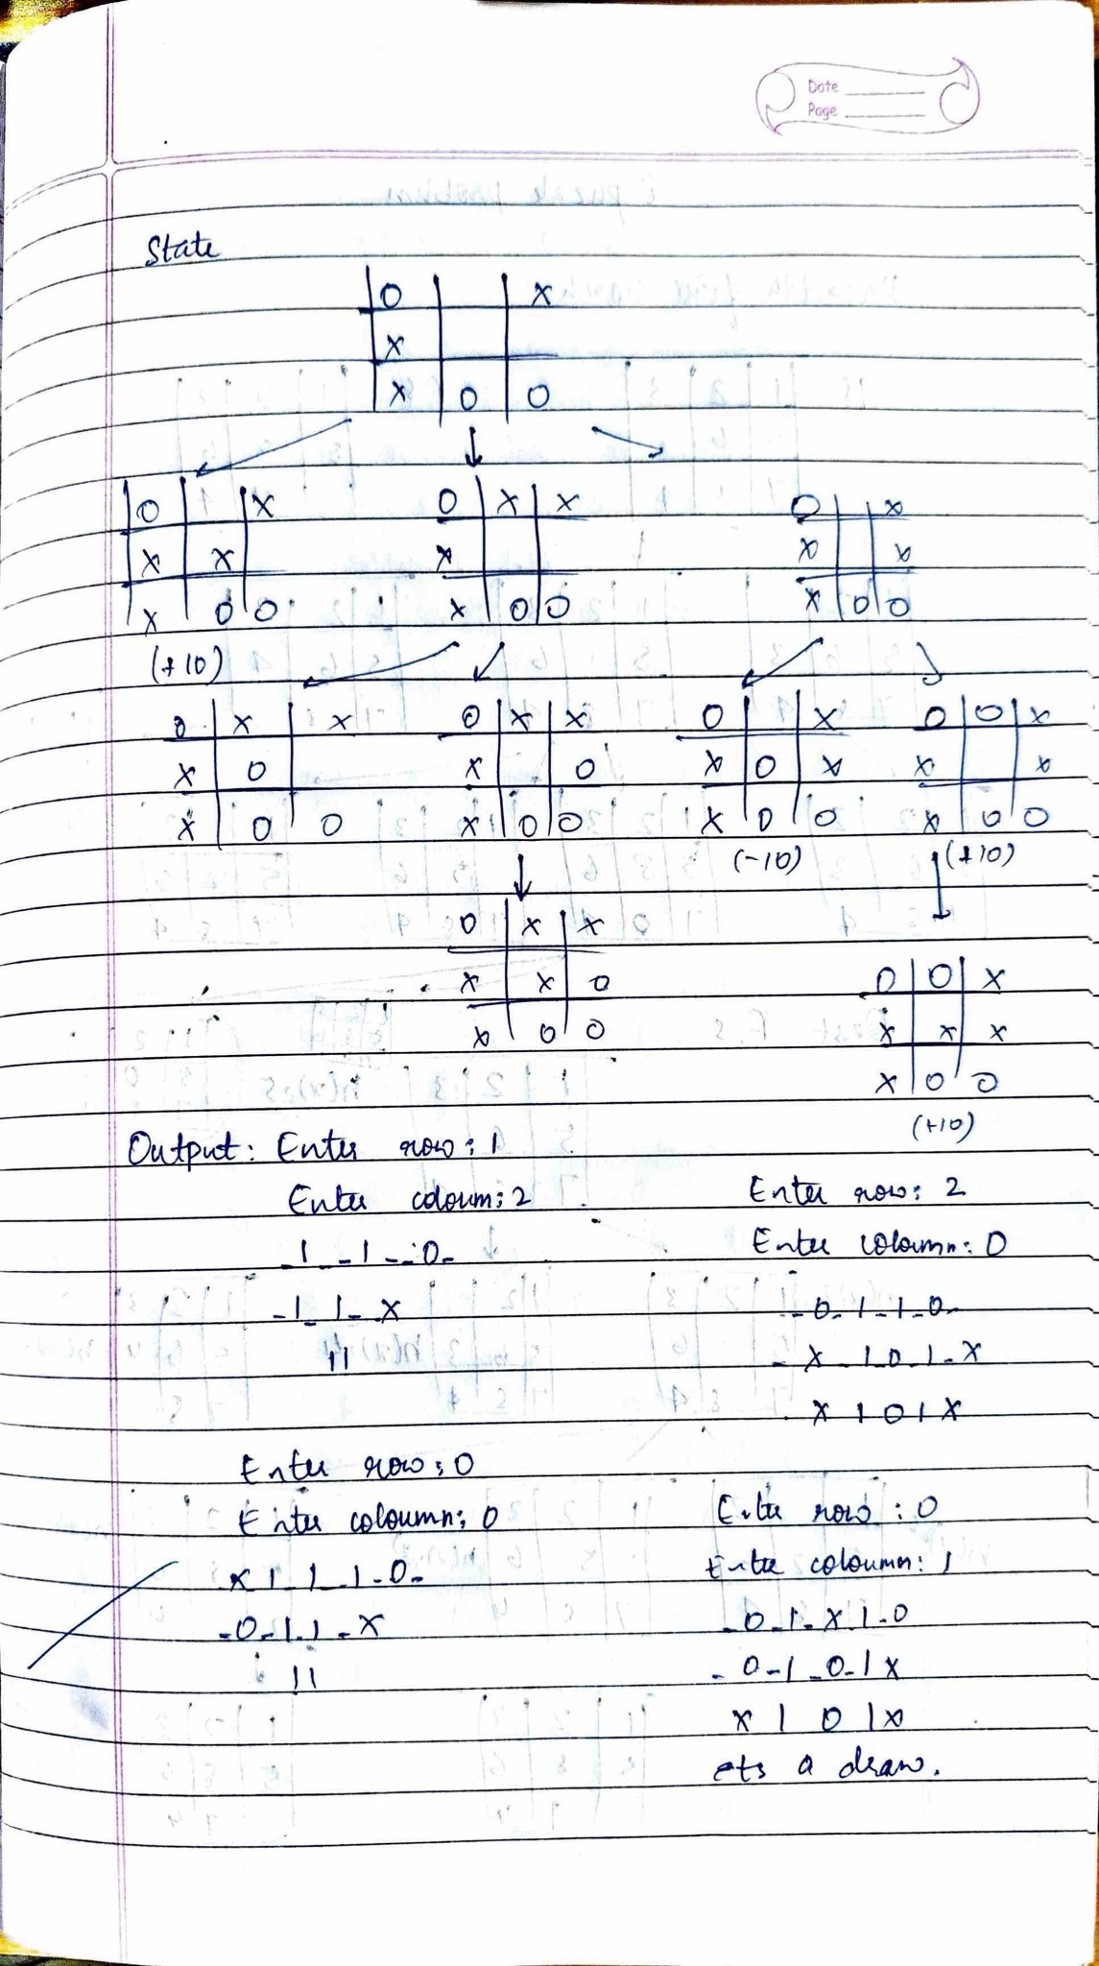

## output

**Program 4:**

**Implement Iteíative deepening seaích algoíithm.(18/12/23)** from collections import defaultdict

# This class represents a directed graph using adjacency # list representation class

Graph:

def init (self,vertices): # No. of vertices

self.V = vertices

# default dictionary to store graph self.graph = defaultdict(list)

self.ans = list()

# function to add an edge to graph def addEdge(self,u,v): self.graph[u].append(v)

# A function to perform a Depth-Limited search # from given source 'src' def

DLS(self,src,target,maxDepth,l): if src == target :

# print(self.ans)

return True

# If reached the maximum depth, stop recursing. if maxDepth <= 0 : return False

# Recur for all the vertices adjacent to this vertex for i in self.graph[src]:

if(self.DLS(i,target,maxDepth-1,l)): l.append(i) return True

return False

# IDDFS to search if target is reachable from v. # It uses recursive DLS()

def IDDFS(self,src, target, maxDepth):

# Repeatedly depth-limit search till the # maximum depth

for i in range(maxDepth):

l = [] if

(self.DLS(src, target, i,l)):

l.append(src)

l.reverse()

return l return l

# Create a graph given in the above diagram n,e = map(int

,input("Enter no.of vertices and edges").split()) g = Graph (n); for i in range(e): a,b = map(int , input().split()) g.addEdge(a,b)

# g.addEdge(0, 1)

# g.addEdge(0, 2)

# g.addEdge(1, 3)

# g.addEdge(1, 4)

# g.addEdge(2, 5)

# g.addEdge(2, 6)

target = int(input("Enter the target vertex")) maxDepth

= int(input("Enter the max depth")) src = 0 l = g.IDDFS(src, target, maxDepth) if len(l)!=0: print(l)

print ("Target is reachable from source " + "within max depth") else

:

print ("Target is NOT reachable from source " + "within max depth")

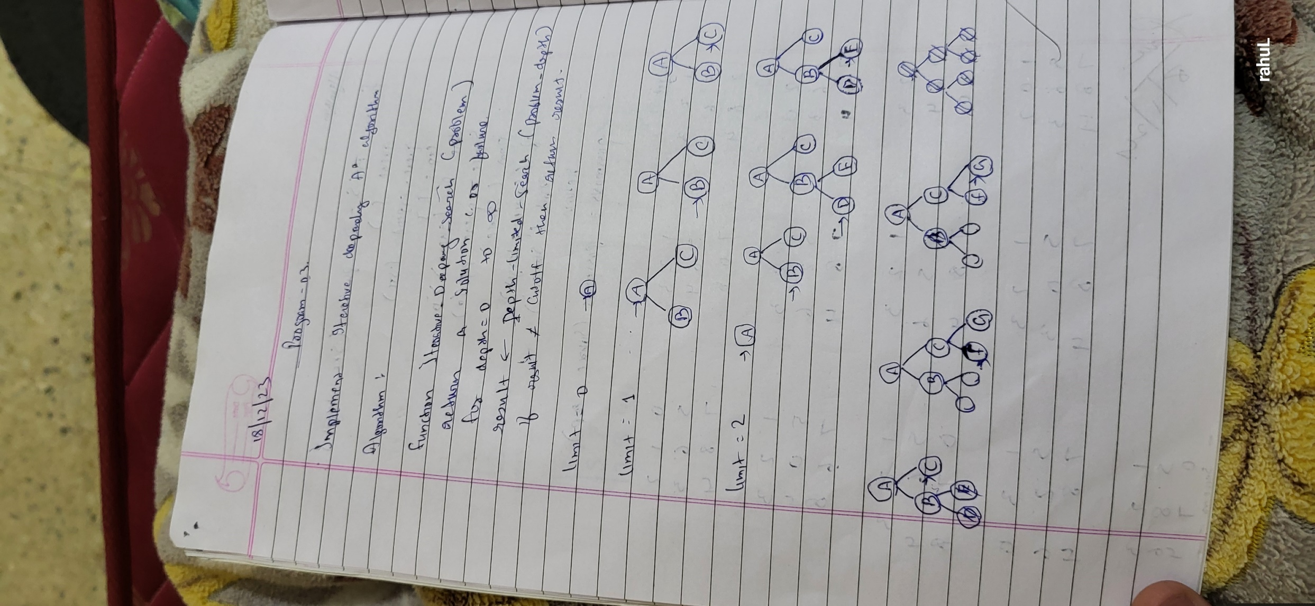

## output

**Program 5:**

#### Implement A* foí 8 puzzle píoblem(8/1/24)

# Online Python compiler (interpreter) to run Python online. # Write Python 3 code in this online editor and run it.

class Node: def init (self,data,level,fval):

self.data = data self.level = level self.fval = fval

def generate_child(self): x,y = self.find(self.data,'_') val_list = [[x,y- 1],[x,y+1],[x-1,y],[x+1,y]] children = [] for i in val_list:

child = self.shuffle(self.data,x,y,i[0],i[1]) if child is not None:

child_node = Node(child,self.level+1,0) children.append(child_node)

return children

def shuffle(self,puz,x1,y1,x2,y2): if x2 >= 0 and x2 < len(self.data) and y2 >= 0 and y2 < len(self.data):

temp_puz = [] temp_puz = self.copy(puz) temp = temp_puz[x2][y2] temp_puz[x2][y2] = temp_puz[x1][y1] temp_puz[x1][y1] = temp return temp_puz else: return None

def copy(self,root): temp = []

for i in root:

t = []

for j in i:

t.append(j) temp.append(t)

return temp

def find(self,puz,x): for i in range(0,len(self.data)): for j in range(0,len(self.data)): if puz[i][j] == x: return i,j

class Puzzle:

def init (self,size): self.n = size

self.open = [] self.closed = []

def accept(self):

puz = [] for i in range(0,self.n): temp

= input().split(" ") puz.append(temp)

return puz

def f(self,start,goal): return self.h(start.data,goal)+start.level

def h(self,start,goal):

temp = 0 for i in range(0,self.n):

for j in range(0,self.n): if start[i][j] != goal[i][j] and start[i][j] != '_': temp +=

1 return temp

def process(self): print("Enter the start state matrix \n") start = self.accept() print("Enter the goal state matrix \n") goal = self.accept()

start = Node(start,0,0) start.fval = self.f(start,goal)

self.open.append(start)

while True:

cur = self.open[0]

print("") print(" | ")--

print(" | ") print(" \\\'/ \n") for i in cur.data: for j in i:

print(j,end=" ") print("") if(self.h(cur.data,goal) == 0):

break for i in cur.generate_child():

i.fval = self.f(i,goal) self.open.append(i) self.closed.append(cur)

del self.open[0]

""" sort the opne list based on f value """ self.open.sort(key = lambda x:x.fval,reverse=False)

puz = Puzzle(3) puz.process()

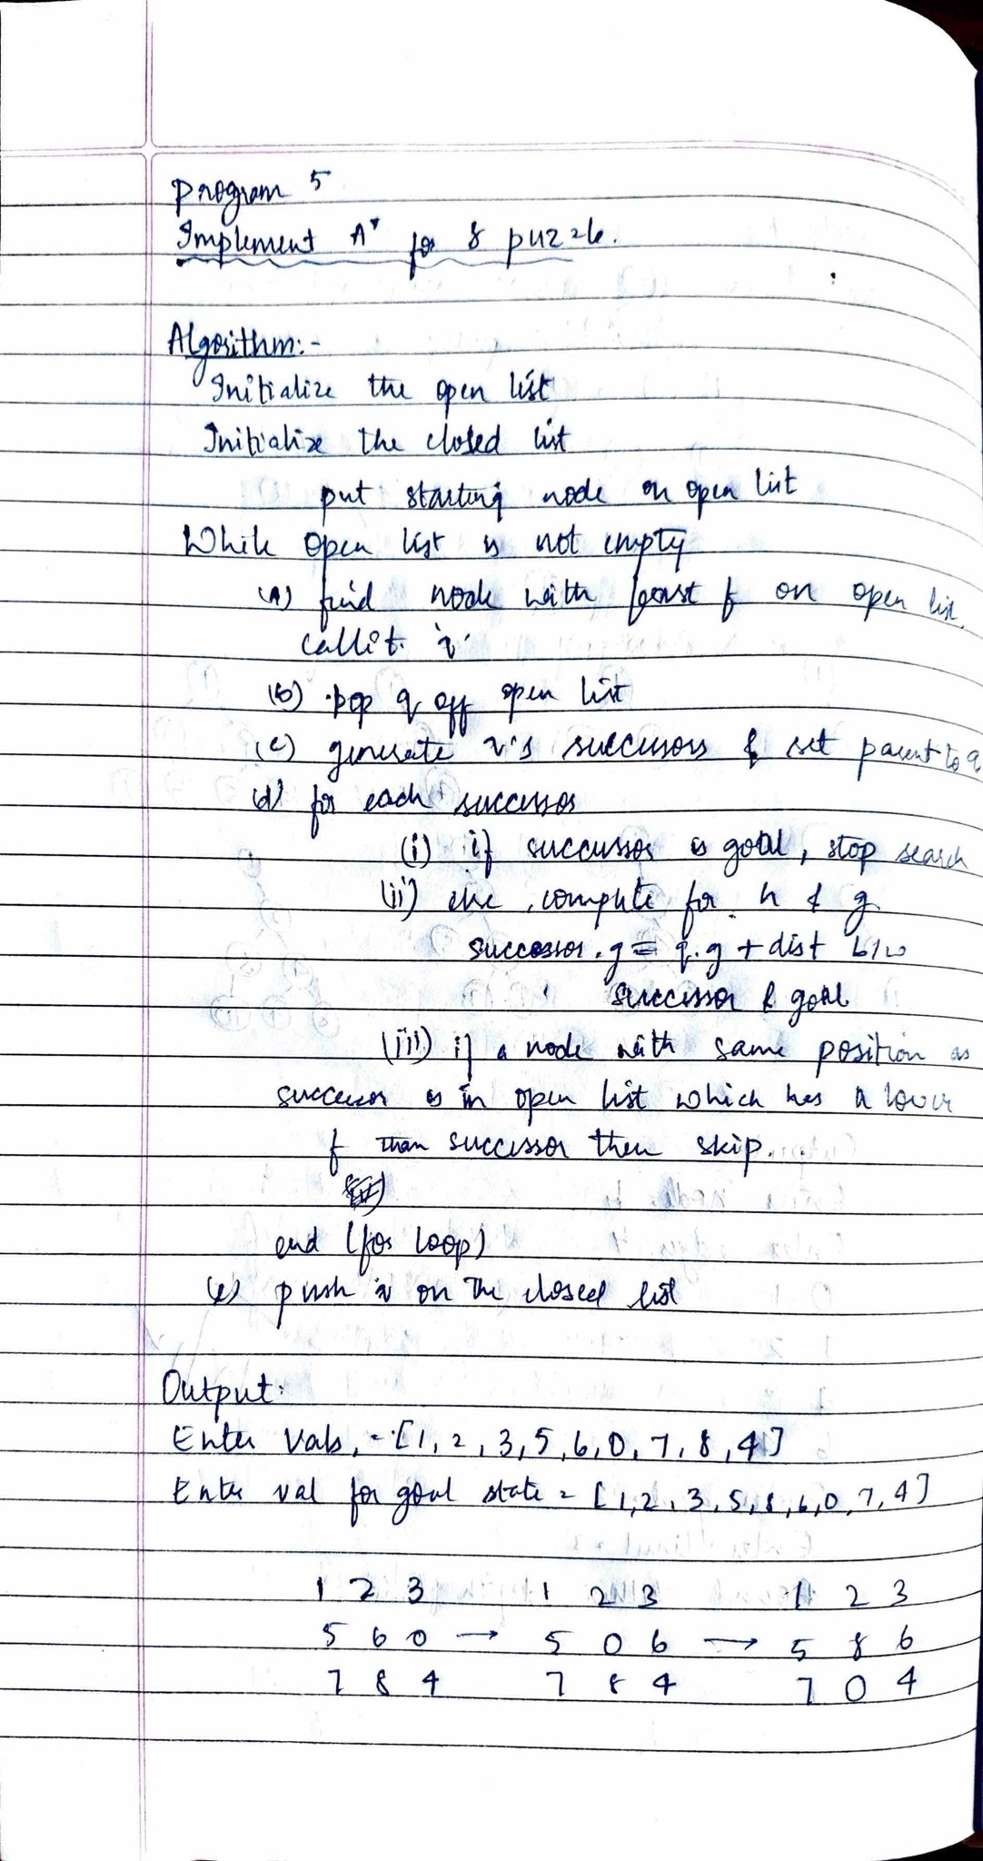

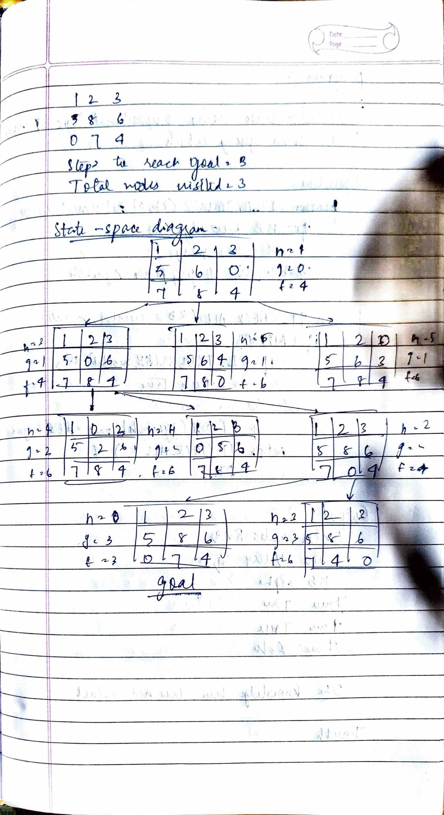

## output

**Program 6:**

**Creation of Knowledge Base using prepositional logic and show that the query entails the KB or not (22/1/24)**

combinations=[(True,True, True),(True,True,False),(True,False,True),(True,False, False),(False,True, True),(False,True, False),(False, False,True),(False,False, False)] variable={'p':0,'q':1, 'r':2} kb='' q='' priority={'~':3,'v':1,'^':2} def input_rules(): global

kb, y kb = (input("Enter rule: ")) y = input("Enter the Query: ") def entailment(): global kb, q

print('*'*10+"Truth Table Reference"+'*'*10) print('kb','alpha') print('*'*10) for comb in combinations: s = evaluatePostfix(toPostfix(kb), comb)

f = evaluatePostfix(toPostfix(y), comb) print(s, f) print('-'*10) if s and not f: return False return True def isOperand(c):

return c.isalpha() and c!='v'

def isLeftParanthesis(c): return c == '('

def isRightParanthesis(c): return c == ')'

def isEmpty(stack): return len(stack) == 0

def peek(stack):

return stack[-1]

def hasLessOrEqualPriority(c1, c2): try:

return priority[c1]<=priority[c2] except KeyError: return False def toPostfix(infix):

stack = [] postfix = '' for c in infix: if isOperand(c): postfix += c else:

if isLeftParanthesis(c):

stack.append(c) elif isRightParanthesis(c): operator = stack.pop() while not isLeftParanthesis(operator):

postfix += operator operator = stack.pop() else: while (not isEmpty(stack)) and hasLessOrEqualPriority(c, peek(stack)):

postfix += stack.pop() stack.append(c) while (not isEmpty(stack)): postfix += stack.pop()

return postfix def evaluatePostfix(exp, comb): stack = [] for i in exp: if isOperand(i):

stack.append(comb[variable[i]]) elif i == '~':

val1 = stack.pop() stack.append(not val1) else:

val1 = stack.pop() val2

= stack.pop() stack.append(_eval(i,val2,val1)) return stack.pop() def _eval(i, val1, val2):

if i == '^':

return val2 and val1 return val2 or val1

input_rules() ans = entailment() if ans: print("The Knowledge Base entails query") else:

print("The Knowledge Base does not entail query")

**output:**

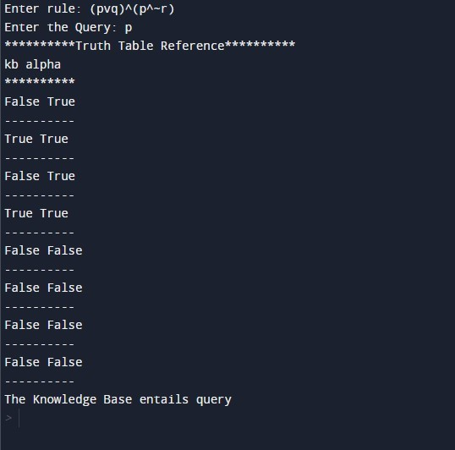

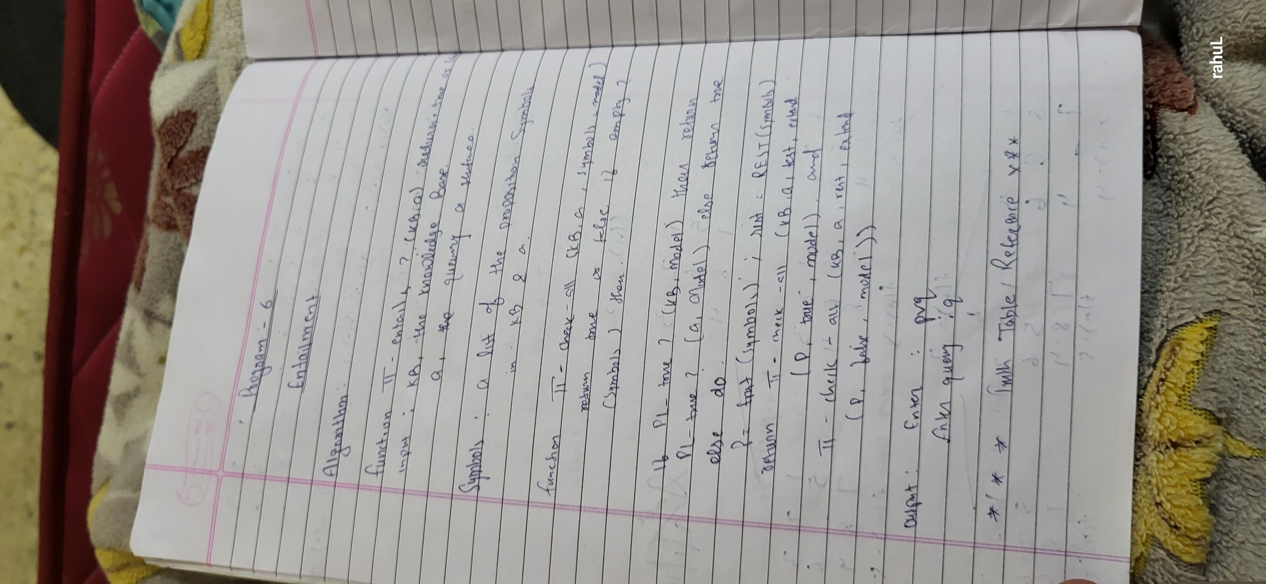

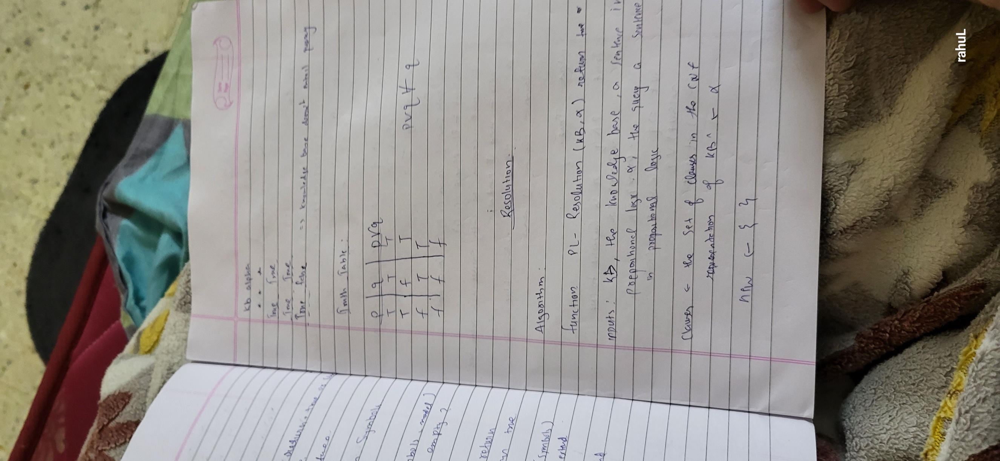

## Program 7:

**Creation of Knowledge Base using prepositional logic and prove the query using resolution(22/1/24)**

kb = []

def CLEAR():

global kb kb = []

def TELL(sentence):

global kb

# If the sentence is a clause, insert directly. if isClause(sentence):

kb.append(sentence)

# If not, convert to CNF, and then insert clauses one by one. else:

sentenceCNF = convertCNF(sentence) if not sentenceCNF: print("Illegal input") return

# Insert clauses one by one when there are multiple clauses if isAndList(sentenceCNF): for s in sentenceCNF[1:]: kb.append(s) else:

kb.append(sentenceCNF)

def ASK(sentence):

global kb

# Negate the sentence, and convert it to CNF accordingly. if isClause(sentence):

neg = negation(sentence)

else:

sentenceCNF = convertCNF(sentence) if not sentenceCNF:

print("Illegal input") return

neg = convertCNF(negation(sentenceCNF))

# Insert individual clauses that we need to ask to ask_list. ask_list = [] if

isAndList(neg):

for n in neg[1:]:

nCNF = makeCNF(n) if type(nCNF). name == 'list':

ask_list.insert(0, nCNF)

else:

ask_list.insert(0, nCNF)

else: ask_list = [neg] clauses = ask_list + kb[:] while True:

new_clauses = [] for c1 in clauses:

for c2 in clauses:

if c1 is not c2:

resolved = resolve(c1, c2) if resolved == False:

continue if resolved == []:

return True

new_clauses.append(resolved)

if len(new_clauses) == 0: return False

new_in_clauses = True

for n in new_clauses: if n not in clauses:

new_in_clauses = False

clauses.append(n)

if new_in_clauses: return False return False

def resolve(arg_one, arg_two): resolved = False

s1 = make_sentence(arg_one)

s2 = make_sentence(arg_two)

resolve_s1 = None resolve_s2 = None

# Two for loops that iterate through the two clauses. for i in s1: if isNotList(i): a1 = i[1]

a1_not = True else: a1 = i a1_not = False

for j in s2: if isNotList(j): a2

= j[1] a2_not = True else:

a2 = j a2_not

= False

# cancel out two literals such as 'a' $ ['not', 'a'] if a1 == a2: if a1_not != a2_not:

# Return False if resolution already happend # but contradiction still exists. if resolved: return False else:

resolved = True

resolve_s1 = i resolve_s2

= j break

# Return False if not resolution happened if not resolved: return False

# Remove the literals that are canceled s1.remove(resolve_s1) s2.remove(resolve_s2)

# # Remove duplicates result

= clear_duplicate(s1 + s2)

# Format the result. if len(result) == 1: return result[0] elif len(result) > 1: result.insert(0, 'or')

return result

def make_sentence(arg): if isLiteral(arg) or isNotList(arg): return [arg] if isOrList(arg): return clear_duplicate(arg[1:])

return

def clear_duplicate(arg): result = [] for i in range(0, len(arg)): if arg[i] not in arg[i+1:]: result.append(arg[i])

return result

def isClause(sentence): if isLiteral(sentence):

return True

if isNotList(sentence): if isLiteral(sentence[1]):

return True

else:

return False

if isOrList(sentence):

for i in range(1, len(sentence)): if len(sentence[i]) > 2:

return False elif not isClause(sentence[i]):

return False return True return False

def isCNF(sentence): if isClause(sentence): return True elif

isAndList(sentence): for s in sentence[1:]: if not isClause(s):

return False return True return False

def negation(sentence): if isLiteral(sentence):

return ['not', sentence] if isNotList(sentence): return sentence[1]

# DeMorgan: if isAndList(sentence): result = ['or'] for i in

sentence[1:]: if isNotList(sentence): result.append(i[1]) else:

result.append(['not', sentence]) return result if isOrList(sentence): result = ['and'] for i in sentence[:]: if isNotList(sentence):

result.append(i[1]) else:

result.append(['not', i]) return result return None

def convertCNF(sentence): while not isCNF(sentence): if

sentence is None: return None sentence = makeCNF(sentence)

return sentence

def makeCNF(sentence):

if isLiteral(sentence):

return sentence

if (type(sentence). name == 'list'):

operand = sentence[0] if isNotList(sentence): if isLiteral(sentence[1]): return sentence cnf = makeCNF(sentence[1]) if cnf[0] == 'not': return makeCNF(cnf[1]) if cnf[0] == 'or': result = ['and']

for i in range(1, len(cnf)): result.append(makeCNF(['not', cnf[i]]))

return result if cnf[0] == 'and': result = ['or'] for i in range(1, len(cnf)):

result.append(makeCNF(['not', cnf[i]])) return result return "False: not"

if operand == 'implies' and len(sentence) == 3: return makeCNF(['or', ['not', makeCNF(sentence[1])], makeCNF(sentence[2])])

if operand == 'biconditional' and len(sentence) == 3: s1 = makeCNF(['implies', sentence[1], sentence[2]])

s2 = makeCNF(['implies', sentence[2], sentence[1]]) return makeCNF(['and', s1, s2])

if isAndList(sentence):

result = ['and'] for i in range(1, len(sentence)): cnf

= makeCNF(sentence[i]) # Distributivity: if isAndList(cnf): for i in range(1, len(cnf)):

result.append(makeCNF(cnf[i]))

continue

result.append(makeCNF(cnf))

return result

if isOrList(sentence):

result1 = ['or'] for i in range(1, len(sentence)): cnf

= makeCNF(sentence[i]) # Distributivity: if isOrList(cnf): for i in range(1, len(cnf)):

result1.append(makeCNF(cnf[i]))

continue

result1.append(makeCNF(cnf)) # Associativity: while True:

result2 = ['and'] and_clause = None

for r in result1: if isAndList(r): and_clause = r

break

# Finish when there's no more 'and' lists # inside of 'or' lists

if not and_clause:

return result1

result1.remove(and_clause)

for i in range(1, len(and_clause)): temp = ['or', and_clause[i]] for o in result1[1:]:

temp.append(makeCNF(o)) result2.append(makeCNF(temp)) result1 = makeCNF(result2)

return None return None

def isLiteral(item): if type(item). name == 'str':

return True return False

def isNotList(item):

if type(item). name == 'list': if len(item) == 2: if item[0]

== 'not': return True return False

def isAndList(item):

if type(item). name == 'list': if len(item) > 2: if item[0]

== 'and': return True return False

def isOrList(item):

if type(item). name == 'list': if len(item) > 2: if item[0]

== 'or': return True return False

CLEAR() TELL('p')

TELL(['implies', ['and', 'p', 'q'], 'r'])

TELL(['implies', ['or', 's', 't'], 'q']) TELL('t') print(ASK('r'))

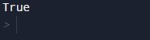Output

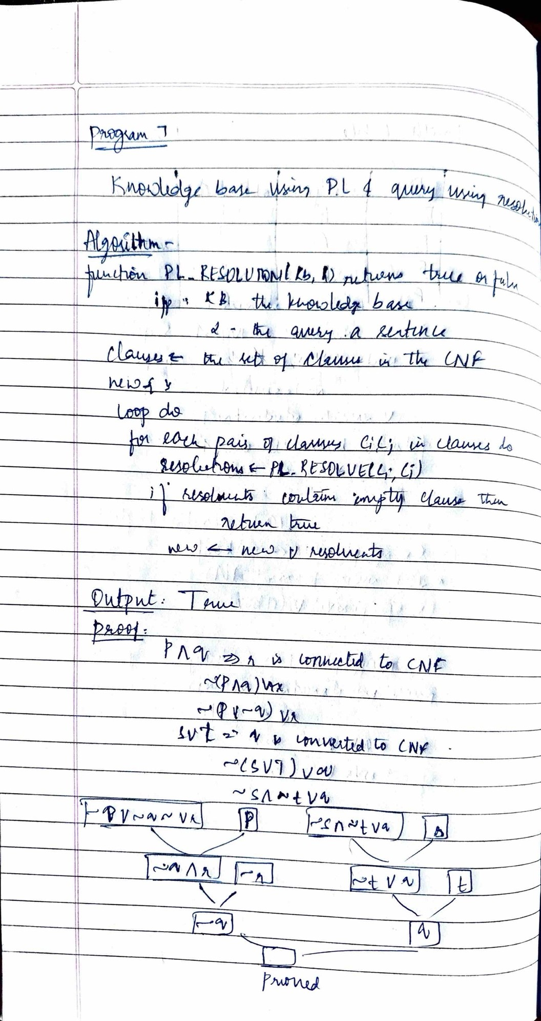

**Program 8:**

# Implement uniﬁcation in ﬁrst order logic(29/1/24)

import re def getAttributes(expression):

expression = expression.split("(")[1:] expression = "(".join(expression) expression = expression.split(")")[:-1] expression = ")".join(expression) attributes = expression.split(',') return attributes

def getInitialPredicate(expression): return expression.split("(")[0] def isConstant(char):

return char.isupper() and len(char) == 1

def isVariable(char): return char.islower() and len(char) == 1 def replaceAttributes(exp, old, new): attributes = getAttributes(exp)

predicate = getInitialPredicate(exp) for index, val in enumerate(attributes): if val == old:

attributes[index] = new

return predicate + "(" + ",".join(attributes) + ")"

def apply(exp, substitutions): for substitution in substitutions:

new, old = substitution exp = replaceAttributes(exp, old, new) return exp def checkOccurs(var, exp): if exp.find(var) == -1:

return False return True

def getFirstPart(expression):

attributes = getAttributes(expression) return attributes[0]

def getRemainingPart(expression): predicate = getInitialPredicate(expression)

attributes = getAttributes(expression)

newExpression = predicate + "(" + ",".join(attributes[1:]) + ")" return newExpression def unify(exp1, exp2): if exp1 == exp2:

return []

if isConstant(exp1) and isConstant(exp2): if exp1 != exp2:

print(f"{exp1} and {exp2} are constants. Cannot be unified") return []

if isConstant(exp1): return [(exp1, exp2)]

if isConstant(exp2): return [(exp2, exp1)]

if isVariable(exp1):

return [(exp2, exp1)] if not checkOccurs(exp1, exp2) else []

if isVariable(exp2):

return [(exp1, exp2)] if not checkOccurs(exp2, exp1) else []

if getInitialPredicate(exp1) != getInitialPredicate(exp2): print("Cannot be unified as the predicates do not match!")

return []

attributeCount1 = len(getAttributes(exp1)) attributeCount2 = len(getAttributes(exp2)) if attributeCount1 != attributeCount2: print(f"Length of attributes {attributeCount1} and

{attributeCount2} do not match. Cannot be unified") return []

head1 = getFirstPart(exp1) head2 = getFirstPart(exp2) initialSubstitution = unify(head1, head2) if not initialSubstitution:

return [] if attributeCount1 == 1:

return initialSubstitution

tail1 = getRemainingPart(exp1) tail2 = getRemainingPart(exp2)

if initialSubstitution != []: tail1 = apply(tail1, initialSubstitution) tail2 = apply(tail2, initialSubstitution)

remainingSubstitution = unify(tail1, tail2) if not remainingSubstitution: return []

return initialSubstitution + remainingSubstitution def main(): print("Enter the first expression")

e1 = input()

print("Enter the second expression") e2 = input() substitutions =

unify(e1, e2) print("The substitutions are:")

print([' / '.join(substitution) for substitution in substitutions]) main()

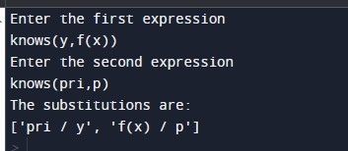

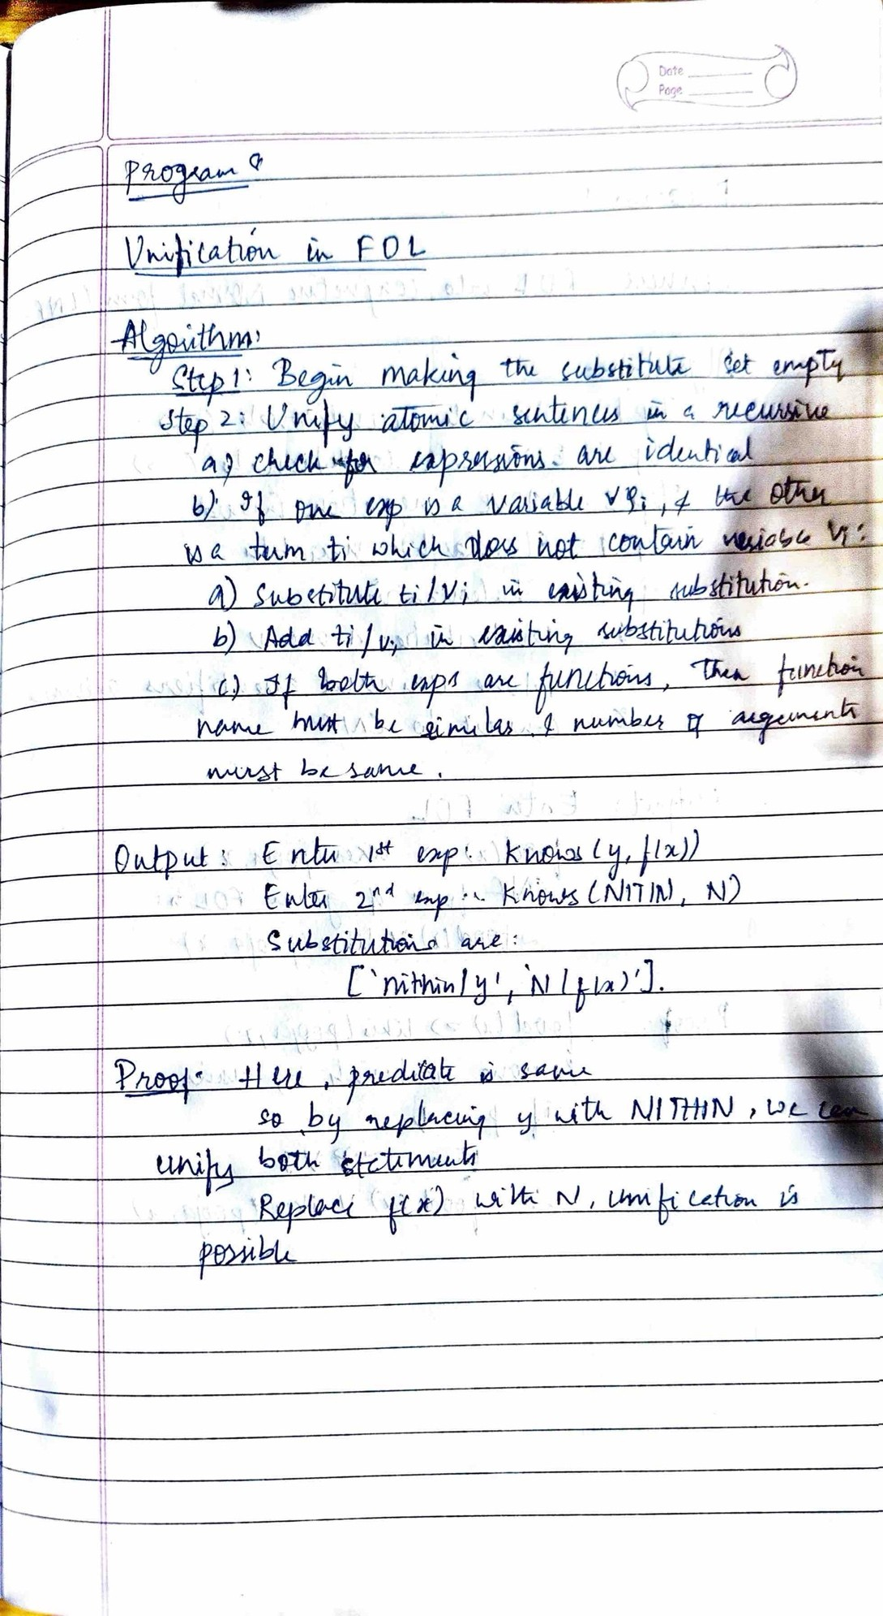

**Program 9:**

### Convert a given ﬁrst order logic statement into Conjunctive Normal Form (CNF).(29/1/24)

import re

def getAttributes(string): expr = '\([^)]+\)'

matches = re.findall(expr, string)

return [m for m in str(matches) if m.isalpha()]

def getPredicates(string): expr = '[a-z~]+\([A-Za-z,]+\)'

return re.findall(expr, string) def

DeMorgan(sentence):

string = ''.join(list(sentence).copy()) string = string.replace('~~','')

ﬂag = '[' in string string = string.replace('~[','') string = string.strip(']') for predicate in getPredicates(string):

string = string.replace(predicate, f'~{predicate}') s = list(string) for i, c in enumerate(string): if c

== 'V': s[i] = '^' elif c == '^': s[i] = 'V' string = ''.join(s) string = string.replace('~~','') return f'[{string}]' if ﬂag else string def Skolemization(sentence):

SKOLEM_CONSTANTS = [f'{chr(c)}' for c in range(ord('A'), ord('Z')+1)] statement = ''.join(list(sentence).copy()) matches = re.findall('[∀∃].', statement) for match in matches[::-1]:

statement = statement.replace(match, '') statements = re.findall('\[\[[^]]+\]]', statement) for s in statements:

statement = statement.replace(s, s[1:-1]) for predicate in getPredicates(statement): attributes = getAttributes(predicate) if ''.join(attributes).islower():

else:

statement = statement.replace(match[1],SKOLEM_CONSTANTS.pop(0))

aL = [a for a in attributes if a.islower()]

aU = [a for a in attributes if not a.islower()][0]

statement = statement.replace(aU, f'{SKOLEM_CONSTANTS.pop(0)}({aL[0] if

len(aL) else match[1]})') return statement def fol_to_cnf(fol):

statement = fol.replace("<=>", "_") while '_' in statement: i = statement.index('_')

new_statement = '[' + statement[:i] + '=>' + statement[i+1:] + ']^['+ statement[i+1:] + '=>' + statement[:i] + ']' statement =

new_statement statement = statement.replace("=>", "-")

expr = '\[([^]]+)\]'

statements = re.findall(expr, statement) for i, s in enumerate(statements): if '[' in s and ']' not in s: statements[i] += ']' for s in statements:

statement = statement.replace(s, fol_to_cnf(s)) while '-' in statement: i = statement.index('-')

br = statement.index('[') if '[' in statement else 0 new_statement = '~'

+ statement[br:i] + 'V' + statement[i+1:] statement = statement[:br] + new_statement if br > 0 else new_statement while '~∀' in statement: i = statement.index('~∀') statement = list(statement)

statement[i], statement[i+1], statement[i+2] = '∃', statement[i+2], '~' statement = ''.join(statement) while '~∃' in statement: i = statement.index('~∃') s = list(statement)

s[i], s[i+1], s[i+2] = '∀', s[i+2], '~' statement = ''.join(s)

statement = statement.replace('~[∀','[~∀') statement = statement.replace('~[∃','[~∃')

expr = '(~[∀V∃].)'

statements = re.findall(expr, statement) for s in statements: statement = statement.replace(s, fol_to_cnf(s))

expr = '~\[[^]]+\]'

statements = re.findall(expr, statement) for s in statements: statement = statement.replace(s,

DeMorgan(s)) return statement def main(): print("Enter FOL:") fol = input()

print("The CNF form of the given FOL is: ") print(Skolemization(fol_to_cnf(fol)))

main()

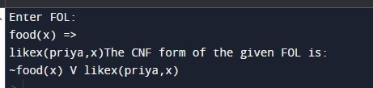

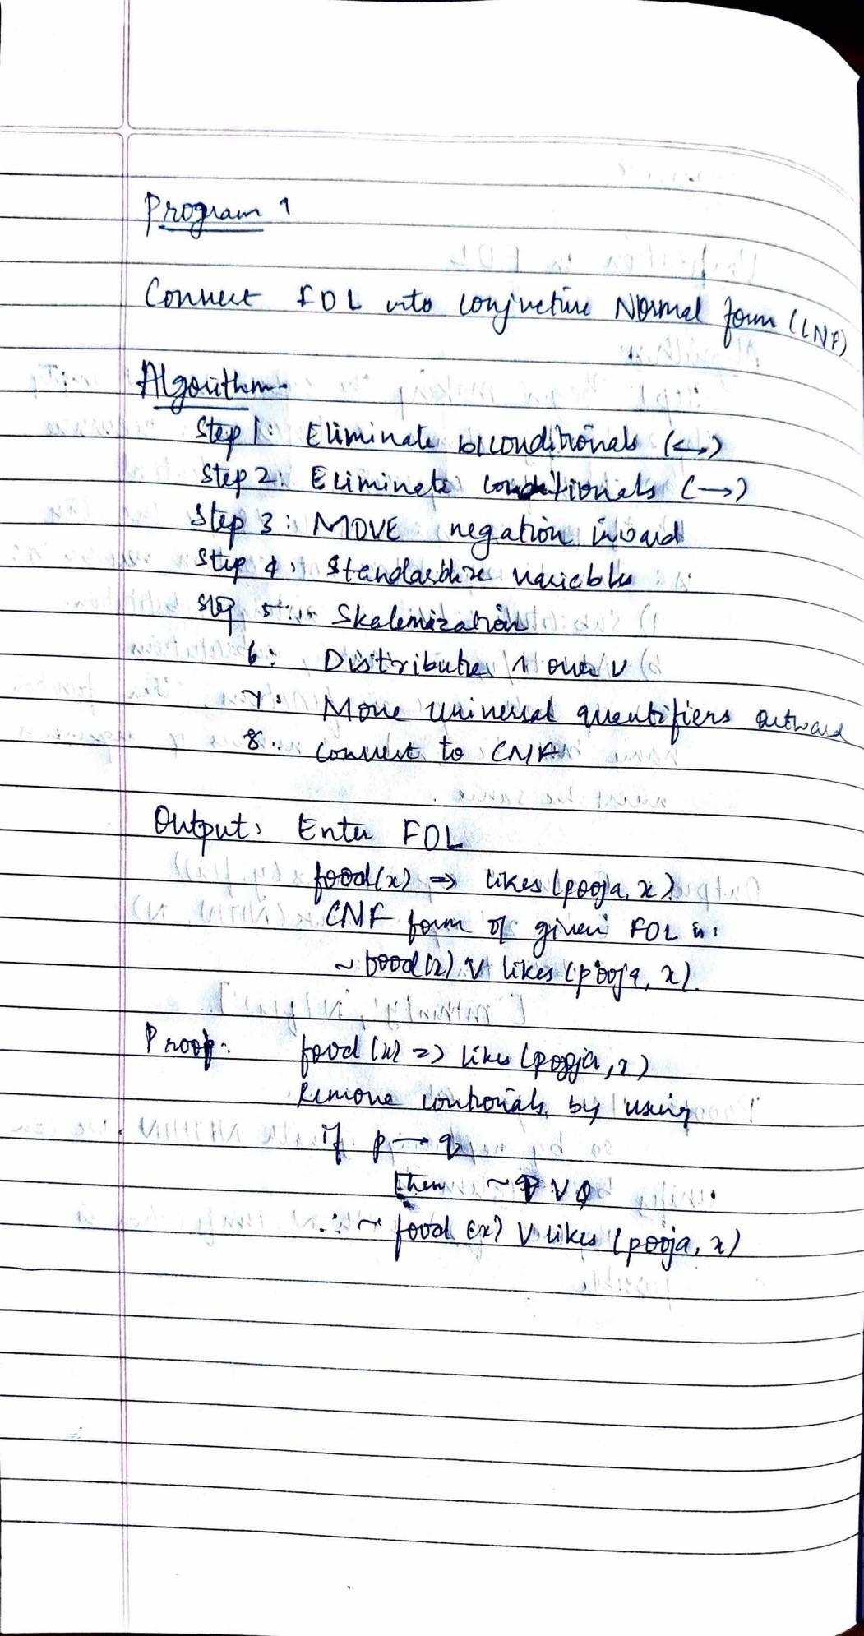

## Program 10:

#### Forward Chaining (29/1/24)

**Code**

import re

def isVariable(x): return len(x) == 1 and x.islower() and x.isalpha()

def getAttributes(string): expr = '\([^)]+\)'

matches = re.findall(expr, string) return matches

def getPredicates(string): expr

= '([a-z~]+)\([^&|]+\)' return re.findall(expr, string) class Fact:

def init (self, expression): self.expression = expression

predicate, params = self.splitExpression(expression) self.predicate = predicate

self.params = params

self.result = any(self.getConstants())

def splitExpression(self, expression):

predicate = getPredicates(expression)[0] params

= getAttributes(expression)[0].strip('()').split(',') return [predicate, params]

def getResult(self): return self.result

def getConstants(self):

return [None if isVariable(c) else c for c in self.params]

def getVariables(self): return [v if isVariable(v) else None for v in self.params]

def substitute(self, constants): c = constants.copy()

f = f"{self.predicate}({','.join([constants.pop(0) if isVariable(p) else p for p in self.params])})" return Fact(f) class Implication:

def init (self, expression): self.expression = expression l

= expression.split('=>')

self.lhs = [Fact(f) for f in l[0].split('&')] self.rhs = Fact(l[1])

def evaluate(self, facts): constants = {} new_lhs = [] for fact in facts: for val in self.lhs: if val.predicate == fact.predicate: for i, v in enumerate(val.getVariables()):

if v:

constants[v] = fact.getConstants()[i] new_lhs.append(fact)

predicate, attributes = getPredicates(self.rhs.expression)[0], str(getAttributes(self.rhs.expression)[0]) for key in constants: if constants[key]:

attributes = attributes.replace(key, constants[key]) expr = f'{predicate}{attributes}'

return Fact(expr) if len(new_lhs) and all([f.getResult() for f in new_lhs]) else None class

KB:

def init (self): self.facts = set()

self.implications = set() def

tell(self, e):

if '=>' in e:

self.implications.add(Implication(e))

else:

self.facts.add(Fact(e))

for i in self.implications:

if res:

res = i.evaluate(self.facts) self.facts.add(res)

def query(self, e): facts = set([f.expression for f in self.facts]) i = 1 print(f'Querying {e}:') for f in facts:

if Fact(f).predicate == Fact(e).predicate: print(f'\t{i}. {f}')

i += 1

def display(self): print("All facts: ") for i, f in enumerate(set([f.expression for f in self.facts])): print(f'\t{i+1}. {f}') def main(): kb = KB() print("Enter KB: (enter e to exit)") while True: t = input() if(t == 'e'): break

kb.tell(t) print("Enter Query:") q

= input() kb.query(q) kb.display() main()

#### Output

